Software Requirements Specification

for
< Discussion Portal>

Version 0.5 approved
Prepared by <Utkarsh Srivastava><U101114FCS150>
<NIIT University>
<16/9/16>
Table of Contents

1. Introduction
1.1 Purpose
1.2 Document Conventions
1.3 Intended Audience and Reading Suggestions
1.4 Product Scope
1.5 References
2. Overall Description
2.1 Product Perspective
2.2 Product Functions
2.3 User Classes and Characteristics
2.4 Operating Environment
2.5 Design and Implementation Constraints
2.6 User Documentation
2.7 Assumptions and Dependencies
3. External Interface Requirements
3.1 User Interfaces
3.2 Hardware Interfaces
3.3 Software Interfaces
3.4 Communications Interfaces
4. System Features
5. Other Nonfunctional Requirements
5.1 Performance Requirements
5.2 Safety Requirements
5.3 Security Requirements
5.4 Software Quality Attributes

Introduction

Purpose
A web portal that will serve as a platform for discussing and posting of
1.Things that are lost or found inside the campus
2.All the events that take place inside the university campus.
Discussion that usually take up a lot of mass mailing and hence this software will act as a substitute.

Document Conventions
The following document is a concise representation of what the plan is all about in creation of the software.
The document contains a table of contents where we have mentioned what the document will contain.
The Document is typographically divided into Headings <Font Style-Times New Roman, Font Size -18,Bold>,Sub-Headings<Font Style-Times New Roman, Font Size-14,Bold > and detailed description in <Font Style-Arial,Font Size- 11,Italic >
Every requirement statement is in its shortest possible form giving a certain insight, and every requirement statement has its own

Intended Audience and Reading Suggestions
The document can act as a insight to the web platform that is to be created and is meant for web developers looking on to basics and thorough summary of how to proceed in creating of online portals for discussions or creating posts.
Project managers who are in need of an online platform where his project members can discuss, Any person who wishes to use such discussion portals.
Documentation writers or bloggers who want to write articles regarding such web platforms.
The SRS is organized in way where we supply sufficient information so as to look upon the software and how it proceeds
The manner in which a reader should proceed with this document is that he or she must be having the knowledge of basic terms about software and its creation

Product Scope
The project is being designed in such a way that all the students and teachers inside the university can discuss about the events that are to be taken place and information is required to be spread to all the members of the university.
Also the phenomenon of lost and found occurs inside every campus and hence this is one necessary thing to post.
The further scope of this product resides in the fact that this can be used by any team or residing group where it is impossible to go and tell it to everyone in person also where emailing is not such an optimized option.
This software will give a separate platform for such discussions giving it a more of profound and optimized implementation of the concept of giving out information to a mass.
This reduces the overthrow of vast emails that one receives every day
Creating such a forum can lead to a proper implementation of issues riding inside the university where response can also be given to the authority holder.

References
The format of the SRS is based on IEEE830 document which describes about as to how a SRS document is to be prepared.

We will be using CSS and Html as for the front end and the UI of the Web portal is to be in a very formal and hence references will be taken for creation of UI.

User Interface will be user-friendly and easy to understand and front end of the portal will be basic.

The Standard of the Portal will be very authentic and formal since it is to be used for university activity purposes

Overall Description

Product Perspective
Inside the University campus there are a lot of activities taking place on a regular basis, and for every large and small activity taking place inside the campus there are emails referring to every activity.
The Admin is disturbed for every small activity that happens throughout the University be it things lost or found by someone to things where certain clubs have some kind of information to tell all people.
While Organizing any event the organizers have to book a certain venue and decide a particular time slot for the event to take place.For this they need a chain of approval from various authorities.
Rather than doing this manually we are trying to convert it to online methodology.
And also will result in reducing the workload of the admin by getting rid of small posts like loss or finding of things inside campus.
This software is basically being prepared to overcome this procedure and hence the user(the regarding authorized personnel) that wants to to convey the information can directly supply the information to the people.

Product Functions
Major functions :
- Login
- Logout

LOST & FOUND(Reporting for things that were lost or found)
User Side:
- Create Post
- View posts
- Edit Post
- Delete Post
- Update Profile
Admin Side:
- Add User
- Remove User
- Review Post
- Approve Post
- Manage Accounts
- Delete Post
- Edit Post
- Report Post to higher authority
Other:
- Authentication
- Notification

EVENT ORGANIZATIONS(Requesting for organization of several events)
User Side
- Create Event
- Select Venue
- Add Time Slot
- Send For Approval
- Edit Venue
- Edit Time Slot
Admin Side:
- Approve Event
- Edit Venue
- Edit Time Slot
- Reject Event
Automatic Functions:
- Notifications
- Auto Generated Email for event
- Delete Event

User Classes and Characteristics
The portal will be accessed by the authorities i.e Teachers and staff of the campus and the students of the university.
User Classes:
- Teachers
- University Staff
- Students
- Club Leaders
- In charges
- Department Heads
Each and every user needs to have a verified user id and password that will be given to the university
Technical Expertise:
System requirements:
Developer Side:
The developer side would require an all time functioning serve with Apache or Sql server running on it(Based on how Developer proceeds further)
Also a knowledge of coding

Database Engine Services
The designed framework as the backend of the website
A security system so that the web portal is not vulnerable.
A Database containing the User Id and Passwords of the User in order to provide a robust authentication

Operating Environment
The web portal will be accessible to any person with:
- Computing device with a fully functional modern operating system
- A valid internet connection
- A web browser installed on the device to access the web portal(Browser which can decode html and CSS scripts and also up to date).
The user will be able to use this portal through the web browser and all front end functionalities will be there in front of the user on the web browser.
This is the first version of this portal.

Design and Implementation Constraints
Constraints:
- People without any proper User Id (registered on the database) won’t be able access it
- People without internet connection won’t be able to access it
- People without basic knowledge of web use won’t be able to access
- The web portal will be limited to members of the organization only
- Posts won’t be published if not approved by the admin
- Post won’t last on portal if deleted by admin(Admin has highest priority in deleting post)
- Web portal won’t work if the server is not setup
- Web portal is required to work 24x7 hence server requires a all time functioning server and also a 24x7 working internet connection
- People without proper web browsers or operating system won’t be able to access
- ENGLISH: primary language of discussion(User must be familiar to it)
- Security :Willing to keep an MD 5 encryption to make the site secure and also one admin access to database in order to achieve secure posting.
- Database(probably MySQL)will be used to keep track of posts created and also the user ID
- The product will be delivered by the developers but its on the organization to maintain the server and handle the database.
- Their will be a particular method as figured by the organization in order to implement the web portal
- Front End HTML5 and CSS
- Backend on C# or PHP

User Documentation
- User Manual to riview the the software working procedure
- Offline help : through the admin of the software and for high end contac the developers
- Tutorial will be given initially to the new users once they sign for the first time

Assumptions and Dependencies
- The SRS is vulnerable to change if the primary client wants to create any changes in the software
- Assumption :The organization is large and conveying information from anyone member to any other is a hectic job.
- Also the University stands in hosting events and events are to keep happening for long time else software is not useful to ghem.
- Third Party priorities won’t effect the software, but the client’s would
- Web Server Application is what the software depends on, and hence its functionalities affect the portal
- The project once implemented can be driven out to several universities and organizations

External Interface Requirements

User Interfaces
As per the requirement of the sodtware the basic user interface lies in the web outlook.. that is the front end of the website.
The UI structure is basic and is divided in the form of hyperlinks to other webpages.
Therefore:
Below are some of the UI designed for using while preperation

The Welcome Home screen
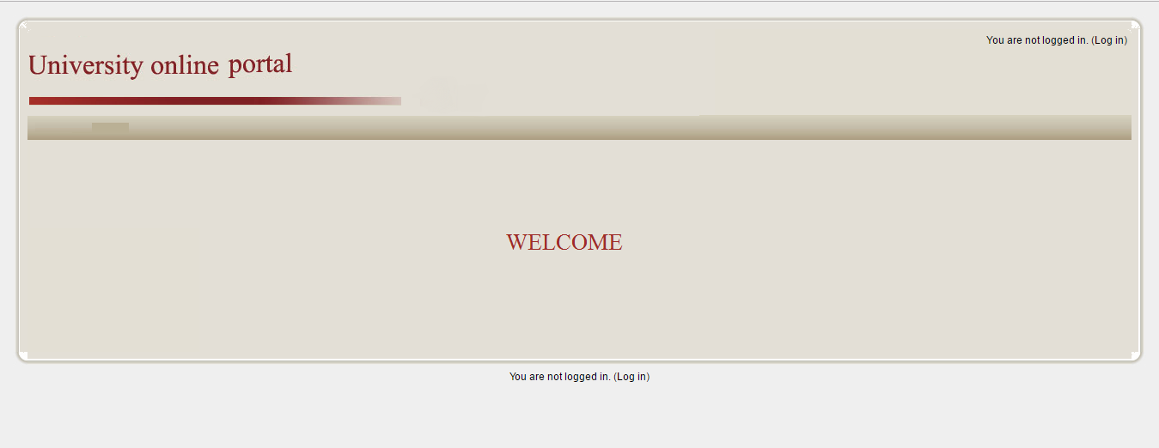

The Login Page:
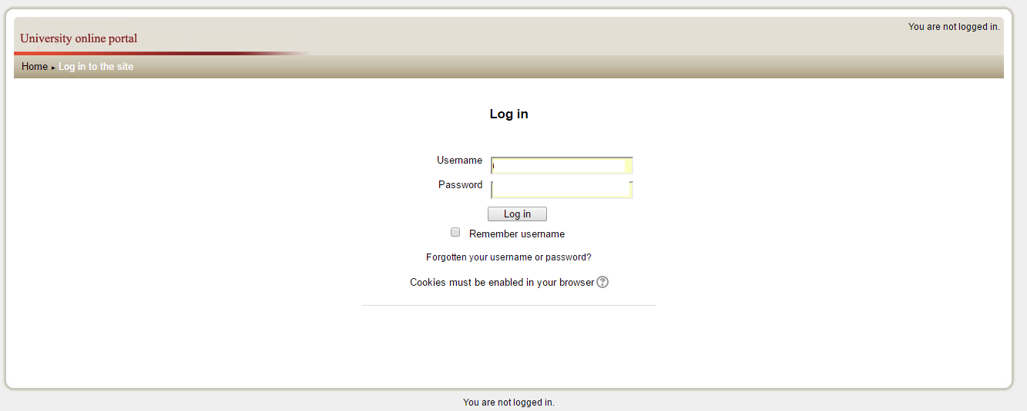

The Post Page

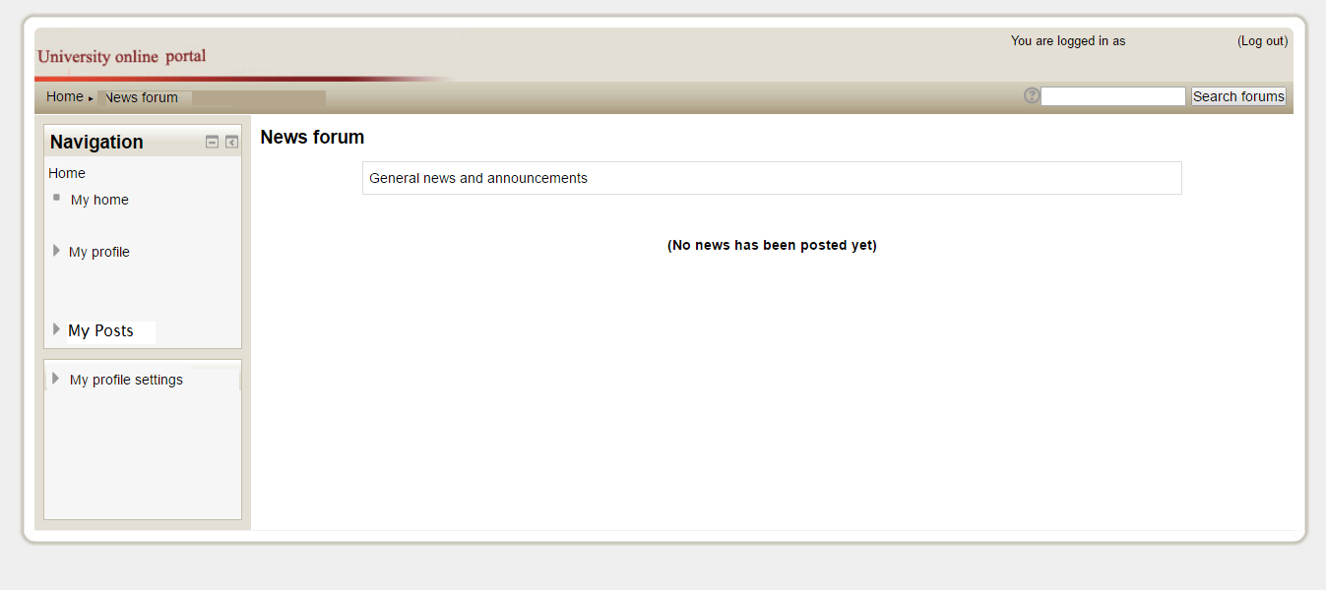

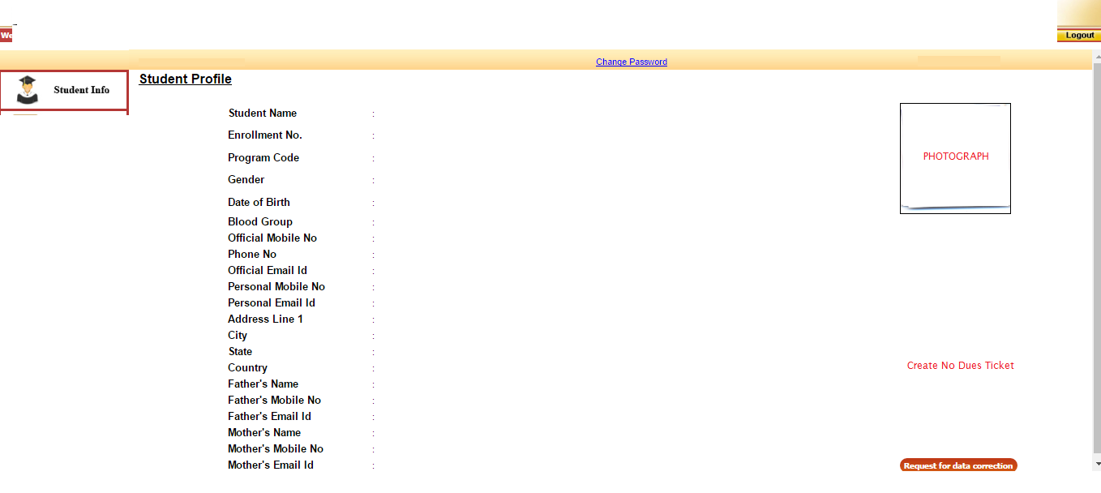

The Profile Page

To Create event request

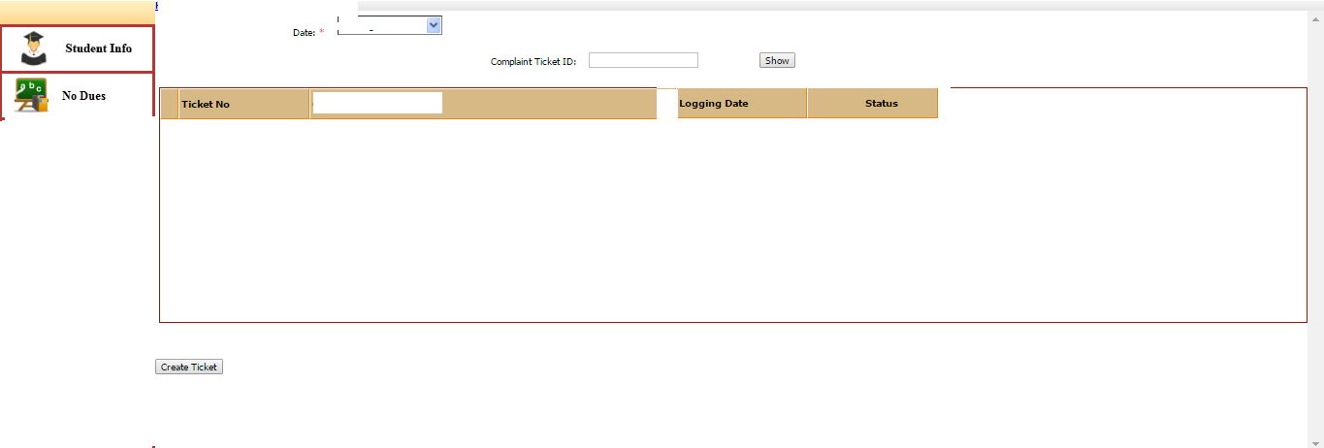
Create

Hardware Interfaces
Since the whole software is web based hence the interface will be designed as per the UI through HTML and CSS.
The logical characteristics behind the web will be framed by C# or PHP ,the back end of the web portal will be designed all the logical functionalities will reside there through the code generated by the developers.
All the activities and functionalities will be managed by the server that will reside at the organization and managed by it.The dataflow will take place from the entries made by the user at his end on his machine and the changes will be updated on the server for further use.

A web page where the users can see the posts made by other people will be there.

A ticket Generation for the event organization will be created.This request will go to another admin(Respected Department- Admin)for approval of the event
This admin will ensure that the event scheduling does not clash with any other event

If verified and none of the events are clashing and event is permissible, the notification will be generated and post will be created for the particular event.
The Interface for the portal will be designed in such a manner that its easy to access.

Software Interfaces
A web page where the users can see the posts made by other people will be there.

There will be web pages separately each for event organization and lost and found feature
The webpages will redirect as per the hyperlink provided on the webpage.
Which further lead to webpages for the various functionalities mentioned in section 2.2
And thus the data submitted by the user on these web pages will be saved on the server with a id link to the user.

The Interface for the portal will be designed in such a manner that its easy to accessand understand.

Communications Interfaces
The product requires the following:
- Web browser interface
- Network Server for the admin and the database stores on the web server
- Media attachment as an option to put on posts
- Formatting post
- FTP used for media uploads
- HTTP for web network
- Desktop or Home screen Notification System if required
- MD5 Encryption or any other prioritized by the customer to secure website
- Data Limit to upload
- Real time based Website
- Synchronization of webpage with the server time
- Proper Monitoring System
- Secure Framewok for Website
- Penetration Vulnerability removal protocol

System Features
USE CASE:

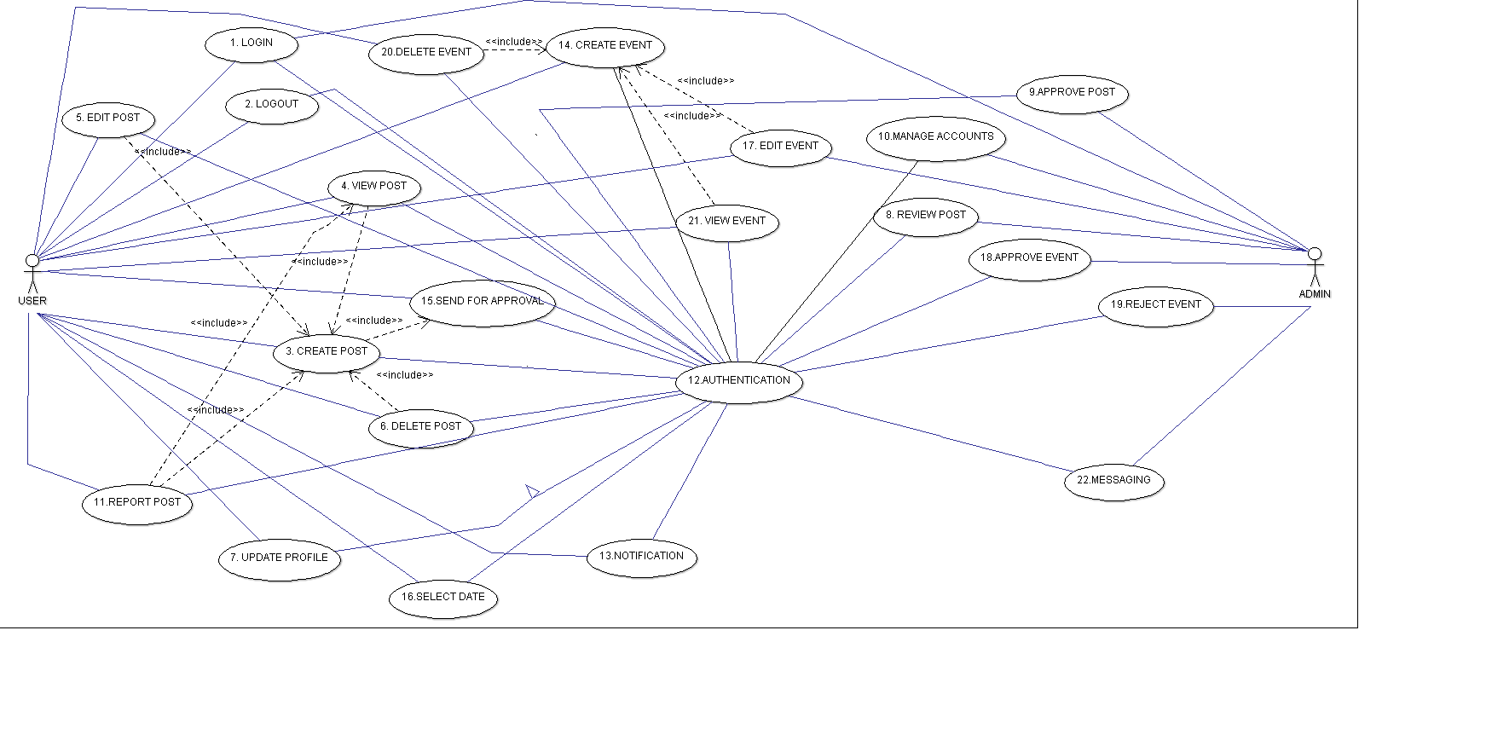
Tabular form of requirements:

Requirement ID | Function | Description
R1 | Login | Login into the portal
R2 | Logout | Logout of the portal
R3 | Create Post | Create a post about item lost or found
R4 | View Post | View the other posts about lost and found by other users
R5 | Edit Post | Edit post created by you before being approved
R6 | Delete Post | Delete the post if the item reaches its respective owner
R7 | Update Profile | Update your profile details
R8 | Review Post | Review the post created by the user
R9 | Approve Post | Approve the post so that it can be displayed on the portal(Chain Approval)
R10 | Manage accounts | Manage All the accounts of the Database(Add,Delete,Disable user tec.)
R11 | Report Post | Any other user reports about the post to the admin
R12 | Authentication | Authentication of the User by the portal
R13 | Notification | Notification being send to the user's device
R14 | Create Event | Create an event to be taken place in the university
R15 | Send for approval | Send the event for approval to the concerned authority
R16 | Select Date | Select the date on which the event is to take place
R17 | Edit Date | Edit the date on which event was previously decided to take place
R18 | Approve Event | Give approval for the event to take place
R19 | Reject Event | Reject the event request
R20 | Delete Event | Delete the event from database(Automatic After the event date expires)
R21 | View Events | View all the events that have been described on the portal
R22 | Messaging | Admin Sends message to user regarding the post or event he created

Here in the above mentioned tabular form :
Major functions:R1,R2(All actors will perform this)
Basic Admin functions:R10,R12
Automatic Actions:R12,R13
Lost & Found:
User Side: R3,R4,R5,R6,R7,R11
Admin: R7,R8,R9,R3,R4,R5,R6,R7
Event Organize:
User:R14,R15,R16,R17,R21
Admin:R14,R16R17,R18,R19,R20,R21,R22

Other Nonfunctional Requirements

Performance Requirements
< The web portal should
- Easy to work upon
- Robust
- User friendly
- Accurate
- Formal
- Secure
- Real time publishing
- Proper database
- Database not be messy
- Fast
- Should be coded such that it takes less memory to load on browser
- Server should be able to handle traffic

Safety Requirements
- The database needs to be secure and only accessible to admin
- Loss of data is only possible if server fails or gets damaged and hence proper management of the server is needed
- MD5 Encryption and Encryption for server
- Penetration testing of the website can further help in making the website better
- Testing server and web for heavy traffic just to ensure that the server does not crash

Security Requirements
- The portal needs security features in order to secure the data that resides on the portal.
- Encryption needs to be done in order to maintain the website secure from hackers
- Proper Maintenance of the server is required.
- Admin access should be encrypted
- Servers not accessible to all
- Privacy is to be there for every single user because he is supplying his information on his profile for his convenience
- Also the media being shared by the people needs to be secure so that it does not go into wrong hands

Software Quality Attributes

Adaptability | The portal needs to be user friendly so that the users can easily adapt to it
Availability | Portal’s avaiibility to be restricted to the member’s of the organization only
Correctness: | Portal should always show correct results and should not mess up and display the content.
Flexibility: | Software should be able to run on all popular platform and be flexible while using
Robustness | The system should be highly tested for robustness as to how it reacts to errors that may come across while functioning of the system
Maintainability | The portal to be designed such a way that it is easy to be maintained
Portability | The product o be designed that it can accessed with least use of equipment and from anywhere in physical space.
Reliability | The software should be in such a way that users rely on it such that it should not have security issues and protocols should be followed freely
Testability | Thorough testing of the software is needed before deploying it,
Usability | The software needs to be user friendly so that the user feel comfortable while using it and hence adapt to it

